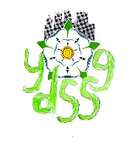
York Down Syndrome Support Group

Parental Consent Form for Use of Images of Children

I/we,…………………………………………………..the parent(s)/guardian(s) of:

(child’s full name)……………………………………………………………………..

(child’s full name)……………………………………………………………………..

(child’s full name)……………………………………………………………………..

hereby give York Down Syndrome Support Group permission to use

- any still and/or moving image being video footage,
- photographs and/or
- audio footage depicting my/our children named above,

Taken by you or on behalf of the York Down Syndrome Support Group, for any of the following uses:

- Publicly viewable pages of our website/social media
- “Members only” pages of on social media
- Promotional leaflets, flyers or posters
- Group produced “new parent” booklets or other publications

(Please delete any of the above that are not applicable)

The above consents will apply throughout the world and be for an indefinite

period / expire on (date).…………………………………….delete as appropriate

Signed………………………………………....Date…………………………………

Signed………………………………………....Date…………………………………

Address………………………………………………………………………………

………………………………………………………………………………………...

Postcode………………………………..

